ART & ACTIVITIES
CLASS
Pre
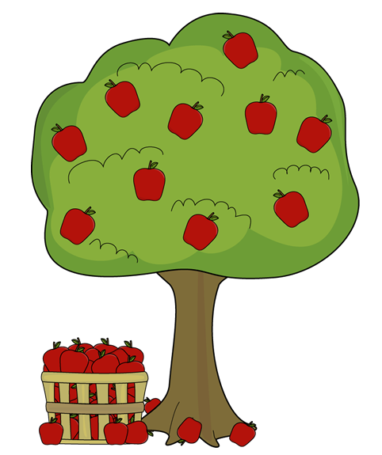
$15 (Non-members)
$8 (Members)
Sunday, November 1st @ 1:00
Mikey’s Play-All-Day Cafe
PreK - Elementary
All About Apples!

